How to bind domain name with dynamic WAN IP of the wireless router
Product line: wireless question category: function config

Q：Why we need to configure the DDNS?
A：If your Internet connection Type is PPPoE or Dynamic IP , the WAN IP Address will change time to time. In order to access the hosting website, FTP server in the LAN of the router at anytime anywhere, we need to bind a domain name with the dynamic WAN IP address.

Steps are as following:
1.Login to the management page of the router.
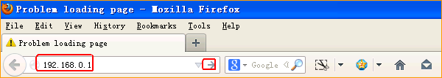

2.Input login password admin(default), to login, then click Advanced
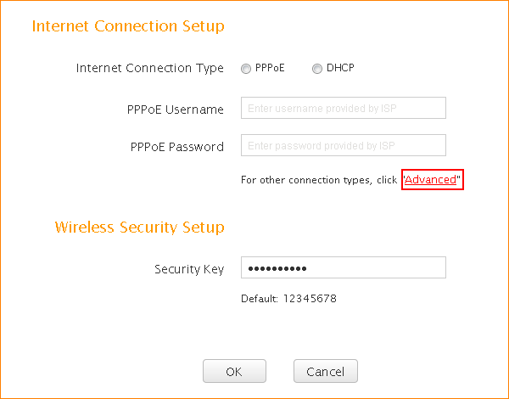

3.Click on Applications, then click DDNS and click Sign up to register a domain name for your WAN IP, then go back to this page to fill in the information.

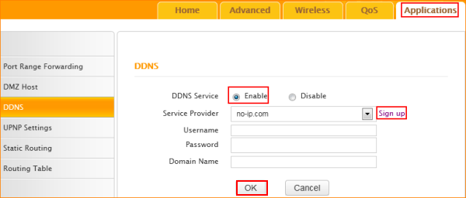

After the settings, you can access the hosting website, FTP server in LAN on the internet with domain name instead of WAN IP address.
For example: ftp://www.tenda.com.cn not ftp://WAN IP

